How to run reports for outstanding Travel Card Transactions

Note: Only a limited number of people have access to run these reports. At least one person in each college/division has been given access.

You can run the following Concur Reports to identify outstanding Travel Card transactions:

Travel Card Transactions – No Expense Reports created
This report will generate a list of Travel Card Transactions that are not assigned to any Expense Reports.

Travel Card Transactions – Expense Reports created but not approved by AP
This report will generate a list of Travel Card transactions that are assigned to Expense Reports but the Expense Reports are not approved by Accounts Payable yet.

- Go to Reporting>Intelligence

- Click on the “University of Houston System” folder.
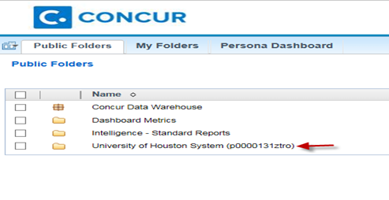

- Click on the “User Reports” folder.

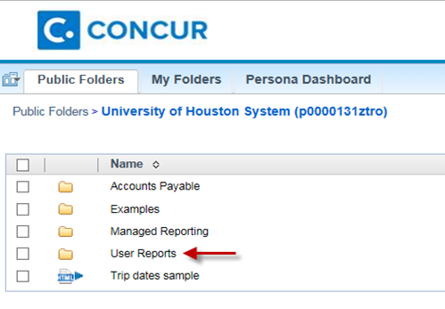

- Click on “Travel Card Transactions – No Expense Reports created” to see outstanding Travel Card transactions that are not assigned to Expense Reports. Click on “Travel Card Transactions – Expense Reports created but not approved by AP” to see outstanding Travel Card transactions which Expense Reports need AP approval.

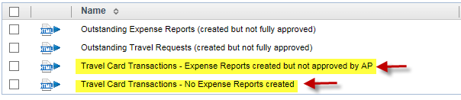

- You will see the screen listing the report result. To generate the report in Excel format, click on and select an appropriate “View in Excel” option. Review the results of both reports.

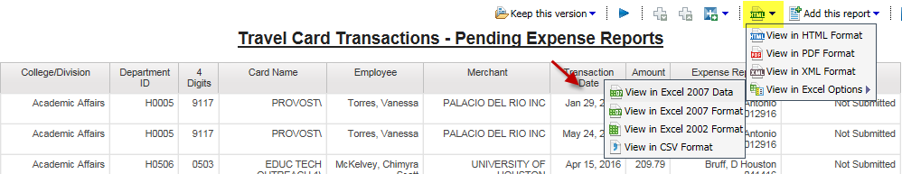

Note: Concur Reports pulls the information as of the previous day. Therefore, if you run the above reports today, you will see the results listed as of yesterday.

